# Section 3.4: Stress

* + We have normal stress and tangential shear stress

# Section 3.5: Cartesian Stress Components

* + 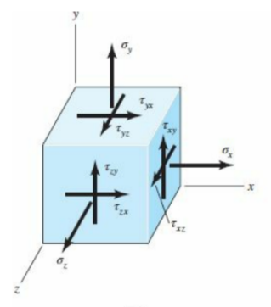
  + In order to keep equilibrium

$τ_{yx}=τ_{xy}$

$τ_{zy}=τ_{yz}$

$τ_{xz}=τ_{zx}$

# Section 3.6 Mohr’s Circle for Plane Stress (one face is )

* + Center $=\frac{σ_{x}+σ_{y}}{2}$
  + Radius $=\sqrt{(\frac{σ_{x}-σ_{y}}{2})^{2}+{τ_{xy}}^{2}}$
  + Principle stresses:
    - Max stress: $σ_{1}=$ Center + Radius
    - $σ_{2}=$ Center - Radius
    - $τ_{max}=$ Radius
  + $ϕ$ is a rotation of the element in the real world
    - $90^{o}$ rotation on mohr circle is $45^{o}$ in real world
    - $tan(2ϕ_{s})= -\frac{σ_{x}-σ_{y}}{2τ_{xy}}$ ${2ϕ}_{s}$ is rotation to get to max shear
    - $2ϕ_{s}-2⋅{45}^{o}$ is rotation to get to principal stress plane ${2ϕ}_{p}$
  + 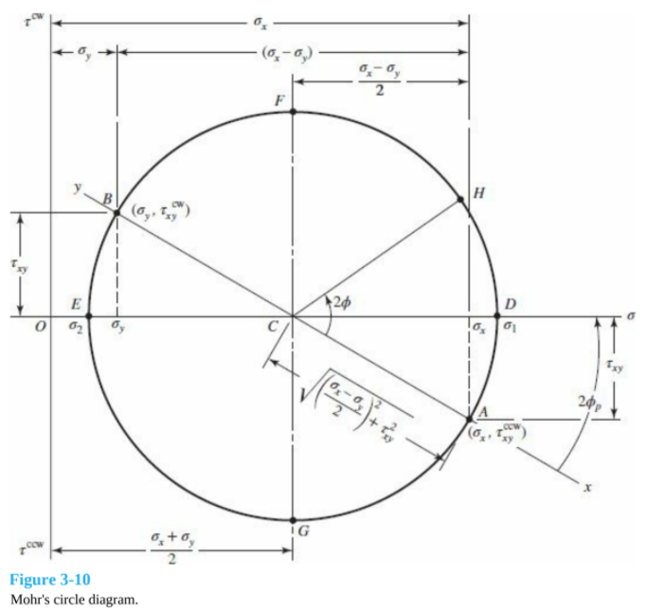

# Section 3.8: Elastic Strain

* + Hooke's Law
 $σ=Eϵ$

 $τ=Gγ$

+ Poisson’s ratio
 $ϵ_{x}=\frac{σ_{x}}{E}$

 $ϵ_{y}=ϵ_{z}= -ν\frac{σ_{x}}{E}$

  - * Negative because positive tension causes swishing in other axis
    - If stress in all three planes

$ϵ_{x}=\frac{1}{E}[σ_{x}-ν(σ_{y}+σ_{z})]$

$E=2G(1+ν)$

# Section 3.10: Normal stresses for beams in bending

* + 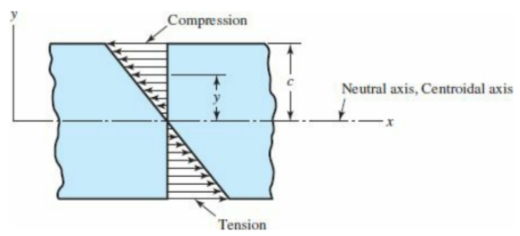
  + 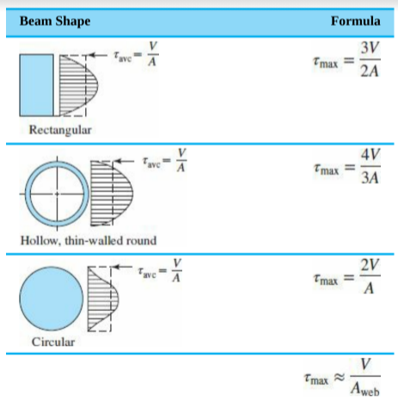
* Shear stresses for beams in bending
  + Transverse shear stress from the vertical shear force

 $τ=\frac{VQ}{Ib}$ $Q=\int_{y_{1}}^{c}{}ydA$

  - Max shear stress occurs along the neutral axis
    - For a rectangular cross section:
 $τ=\frac{V}{2I}(c^{2}-{y_{1}}^{2})$

   - Last one in the table is for thin-walled I beams
  + Remember to do a mohr’s circle to find true maxes based off of element rotation
    - $τ_{max}=\sqrt{{(\frac{σ}{2})}^{2}+τ}$ 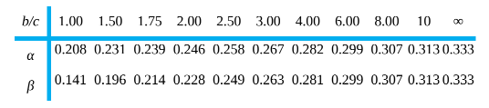

# Section 3.12: Torsion

* + Circular cross section
 $θ=\frac{Tl}{GJ}$ $τ_{max}=\frac{Tr}{J}$

+ Rectangular cross section ($b×c$), $b$ is longest side

$θ=\frac{Tl}{βαc^{3}G}$ $τ_{max}=\frac{T}{αbc^{2}}≈\frac{T}{bc^{2}}(3+\frac{1.8}{b/c})$